Postal Life Insurance

Department of Post

Software Requirements Specification (SRS)/ Functional Requirements Specification (FRS)
Duplicate Policy Bond

INTERNAL APPROVAL FORM

Project Name: Duplicate Policy Bond
Version: 1.0
Submitted on:
 | Name | Date
Approved By:
Reviewed By:
Prepared By:

VERSION CONTROL LOG
Version | Date | Prepared By | Remarks
1

Table of Contents

1. Executive Summary 4
2. Project Scope 4
3. Business Requirements 4
4. Functional Requirements Specification 5
4.1 Non-Financial Service Request Indexing page 5
4.2 Duplicate Policy Bond Page 6
5. Attachments 6

1. Executive Summary
This document outlines the functional and non-functional requirements for implementing the Duplicate Policy Bond feature in Insurance Management System. The goal is to digitize and streamline the issuance of duplicate policy bonds, ensuring security, traceability, and compliance.

2. Project Scope
The feature will allow customers to request duplicate policy bonds through multiple channels, enable secure identity verification, automate approval workflows, and ensure secure issuance and dispatch of the duplicate bond.

3. Business Requirements

ID | Requirements
FS_DPB_001 | Enable customers to request duplicate bonds via portal, mobile app, agent portal and app, or branch, capturing essential policy and identity details.
FS_DPB_002 | Verify identity using OTP/eKYC and allow digital upload and validation of FIR and indemnity documents.
FS_DPB_003 | Generate duplicate bonds with digital watermark and signature, maintaining version history for traceability.
FS_DPB_004 | Provide both digital and physical dispatch modes with integrated tracking through India Post systems.
FS_DPB_005 | Ensure complete audit trails and retain records for compliance standards.

4. Functional Requirements Specification
Flow Diagram for Duplicate Policy Bond Process: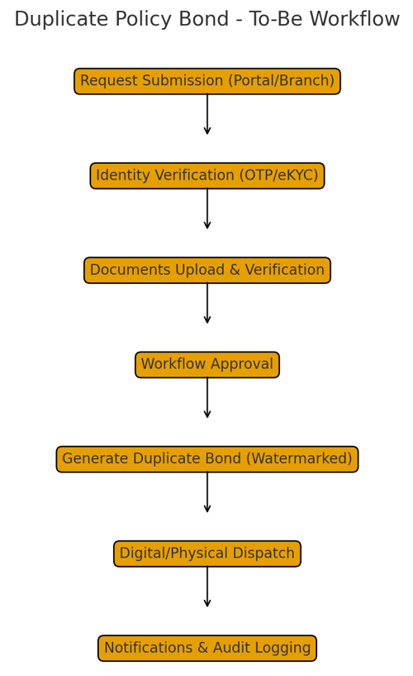

4.1 Non-Financial Service Request Indexing page
- Purpose: To create Non-Financial Service Request for Duplicate Policy Bond Page.
- Fields:
  - Request Type: Option should include service request type like Duplicate Policy Bond, etc.
  - Service Request Date: Calendar: Date on which service request is indexed.
  - Policy Number: Text
  - Office Code: Text: Facility ID of the office where request is getting indexed
  - Service Request Channel: Text: Channel for the service request like RICT, CP etc.
  - Username: Text: Emp ID of the user indexing the request
- Rules:
  - Request should get created and CPC User should be able to open the details.

4.2 Duplicate Policy Bond Page
- Purpose: To send the Duplicate Policy Bond for the Policy.
- Field:
  - Request Type: Auto-Populated
  - Ticket No.: Auto-Populated
  - Policy Number (auto-validated)
  - Request Date: Calendar: Editable
  - Reason: Dropdown: Options for issuing duplicate policy bond like Destroyed due to Fire, etc.
  - Fee Received: Checkbox
  - List of Documents: Multiple checkboxes for ‘ID and Address Proof’, ‘Indemnity Bond’, ‘Copy of FIR’, ‘Certificate from fire authorities’, ‘Certificate of Unit Commanding officer’, ‘Copy of Notice of loss published in Newspaper’, ‘Waive Documents’.
  - Add Documents: button: Option to upload the documents.
  - Add Comments: Button: Option to add comments after clicking this button
  - Submit: Button
- Rules:
  - Clicking on Submit button should generate a downloadable PDF of Policy Bond which can be printed and given to Customer.

5. Attachments
The following documents can be referred.

